**Fonwood ECC 2022-2023 Dress Code Policy**

Students at Fonwood Early Childhood Center are expected to wear the school uniform every day.

* On Fridays the student can wear their favorite university shirt or Fonwood spirit shirt with khaki bottoms.

Our goal is to be proactive and avoid having to ask parents/guardians to bring the school uniform to the school for their son or daughter by asking you to read the information below.

***The information below guarantees that all Fonwood cubs are dressed for success.***

**Girls**

* Khaki shorts, skirts, pants, jumpers and skorts
* 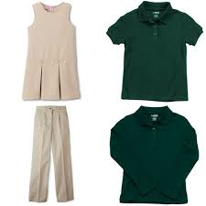Hunter green short/long sleeve polo knit shirt
* Fonwood ECC Polo Shirt or Fonwood ECC T-shirt
* Skirts and skorts should be knee length
* Close toe, comfortable shoes (Velcro shoes recommended)

**Boys**

* Khaki shorts or pants
* Hunter green short/long sleeve polo knit shirt
* Fonwood ECC Polo Shirt or Fonwood ECC T-shirt
* Close toe, comfortable shoes **(Velcro shoes recommended)**

**All**

**Fonwood ECC students are required to wear the school issued backpack daily as part of their uniform. NO**

**EXCEPTIONS!**

**The** **following are NOT allowed:**

* Crocs,Open toe, flip flops, sandals or high heels
* Large or dangling earrings on girls
* Any clothing displaying inappropriate language, pictures, or themes

***IN CASE OF ACCIDENTS***

***Parents should send a change of clothes including socks, underwear, pants, skirt or dress in a gallon-sized bag. All Soiled clothing will be returned in the gallon size bag if an accident occurs. Once the items are used, please send a replacement set so that your child always has extra clothing on hand.***